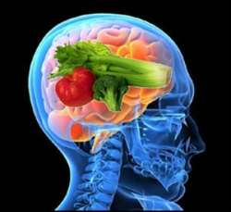

Inside This Packet

1 Omega-3 and the Brain

2 Sleep Hygiene/ Journal

3 Exercise Tips/ Planning

4 Nutrition Advice/ Support

~ Alexander Holmes, RN, BSN, QMHP



“In minds crammed with thoughts, organs clogged with toxins, and bodies stiffened with neglect, there is just no space for anything else.”  ~Alison Rose Levy

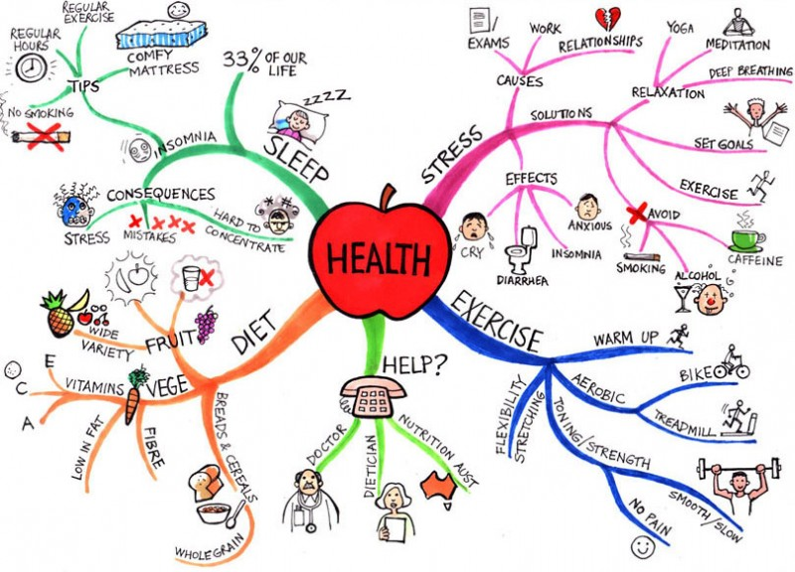

**“A nurse? Why do I need a nurse?” “I don’t have time for that.”**

**“I already have a doctor!” “I hate doctors!”**

**“I don’t want to take medications!”**

**I hear these comments all the time and I am here to tell you that it’s ok to feel that way or all of those ways. I am here to help you find your health goals and achieve them. We all struggle to sleep, eat, and exercise better. But with a little help and some perseverance you can be an active member in your recovery by taking control of your health. Look through this packet and come see me with questions!**

*!*

# Nursing Support in EASA/HUB

Creating a  
Healthy You